Capstone II Software Documentation

*Blake Martin*

*Reese Meadows*

*Keaton Shelton*

*Josh White*

*Johnathon Longmire*

**User Documentation**

**Introductory Information / Walkthroughs**

*Accessing the Source Code Repository*

* *The source code for the Aurora seizure detection mobile application, along with some useful wiki pages and the past issues worked & history of development can be found at* [*https://github.com/mbmartin44/Aurora-2022.git.*](https://github.com/mbmartin44/Aurora-2022.git.)
* *For simplest access, the zip file contained in the deliverables folder contains all the source code for the project.*
* *To continue development with this archived repository, simply fork the repository on GitHub, or begin from the zip file provided from the instructor.*
* *See* [*https://docs.github.com/en/get-started/quickstart/fork-a-repo*](https://docs.github.com/en/get-started/quickstart/fork-a-repo) *for instructions on forking a repository.*
* *For additional assistance, contact Blake Martin at* [*mbmartin44@tntech.edu*](mailto:mbmartin44@tntech.edu)*.*

*Establishing a Connection with the Headband*

* *Once the user has acquired the headband and the mobile device, to test the application, go to the main page of the phone and open the “Aurora” app.*
* *To enable the full functionality of the system, make sure to configure all the permissions that are presented as options in the settings, such as location and messaging permissions.*
* *Once the battery is inserted into the headband, opening the application should begin the Bluetooth connection process, as the headband comes with firmware controlling its setup, run, and sleep modes.*
* *Once a Bluetooth connection has been established, the application should switch from the “Device Searching” screen, to the main menu of the application.*

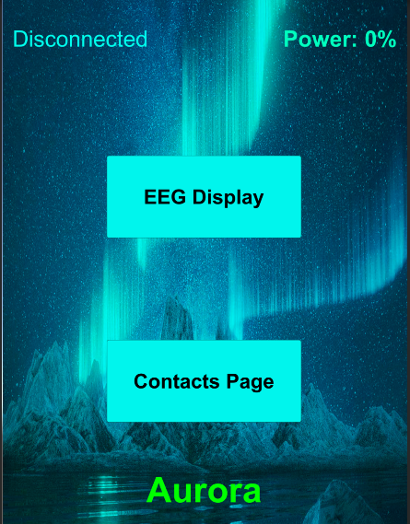

* *At this point, if you select the EEG Display button in the application, EEG signals should begin streaming from the headband and be visible in the real-time plots*

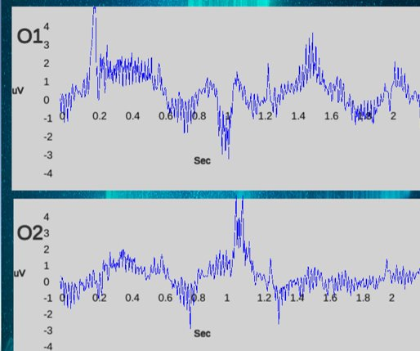*.*

* *From this point on, the connection will be maintained until the application is closed (or until the headband dies).*

*Adding and Removing Contacts*

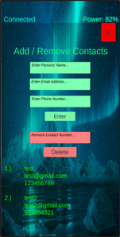

* To add or remove contacts from the contacts page, first select the “Contacts Page” button within the application.
* Once the contacts page has been selected, new contacts can be added by simply selecting the Name, email address, and phone number text boxes, entering the information as prompted, and pressing the Enter button.
* The visual indicator that a new contact was successfully added is the addition of a new entry in the list at the bottom of the page.
* Contacts are saved between runs of the application, so to delete them, you should add the name of the contact you wish to delete and press the “remove” button.

Software Documentation (Development Tutorials)

*Getting Started with Unity*

* *For instructions on getting started with Unity, follow this link to a wiki tutorial found in the repository,* [*https://github.com/mbmartin44/Aurora-2022/wiki/Unity-Installation-&-VS-Integration-Tutorial*](https://github.com/mbmartin44/Aurora-2022/wiki/Unity-Installation-&-VS-Integration-Tutorial)*.*

*VS2019 Integration Tutorial*

* *Instructions for downloading and installing VS2019:* [*https://www.tektutorialshub.com/visual-studio/how-to-download-and-install-visual-studio-2019/*](https://www.tektutorialshub.com/visual-studio/how-to-download-and-install-visual-studio-2019/)

*LLE Algorithm MATLAB Notes*

* *Instructions for the testing and verification MATLAB script can be found in the repository, https://github.com/mbmartin44/Aurora-2022/wiki/Validation-and-Verification-Wiki-Homepage*

*LLE Subsystem Information*

* *Information regarding the implementation of the Rosenstein Largest Lyapunov algorithm can be found here at:* [*https://github.com/mbmartin44/Aurora-2022/wiki/L1D2-Library-Information*](https://github.com/mbmartin44/Aurora-2022/wiki/L1D2-Library-Information)

*Networking Subsystem Information*

* *Information regarding the implementation of the Networking Subsystem can be found here at:*

[*https://github.com/mbmartin44/Aurora-2022/wiki/Networking-Project-*](https://github.com/mbmartin44/Aurora-2022/wiki/Networking-Project-Homepage) *Homepage*